**STEPS**

1. Open Visual C++ and click the New item in the File menu and a new dialog box is opened
2. Now select “MFC AppWizard (exe)” entry
3. Give the new Project name in the Project name box and click OK. Clicking OK will start the Visual C++ AppWizard

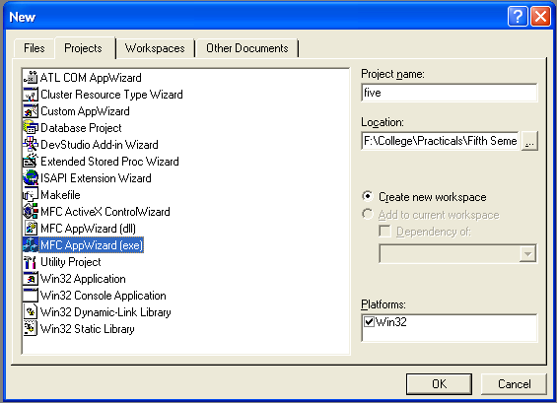

1. We will accept all defaults except one- by default, AppWizard creates Multiple Documents program and we will change so that it creates a Single Document program

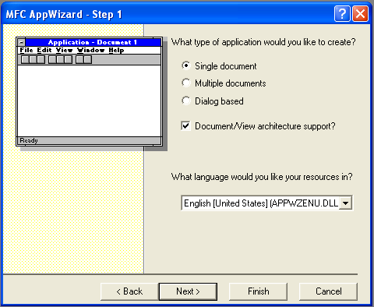

1. The AppWizard is asking for what database we want in our program; we will do “None” option selected. Keep pressing next until project information box is opened.
2. In the document header file, fivedoc.h:

class CFiveDoc : public CDocument

{

protected: // create from serialization only

CFiveDoc();

DECLARE_DYNCREATE(CFiveDoc)

* CString StringData;

.

.

.

.

}

1. Next we initialize the StringData object in the fivedoc.cpp file:

CfiveDoc :: CfiveDoc

{

* StringData="";

}

1. Select the Class Wizard item in the View menu and Class Wizard dialog box is opened
2. Select Class name CFiveView and select WM_CHAR to select OnChar() method

void CFiveView::OnChar(UINT nChar, UINT nRepCnt, UINT nFlags)

{

// TODO: Add your message handler code here and/or call default

* CFiveDoc *pDoc=GetDocument();
* ASSERT_VALID(pDoc);
* pDoc->StringData+=nChar;
* Invalidate();

CView::OnChar(nChar, nRepCnt, nFlags);

}

1. Now open OnDraw() method from the CFiveView class:

void CFiveView::OnDraw(CDC* pDC)

{

* CFiveDoc* pDoc = GetDocument();
* ASSERT_VALID(pDoc);
* pDC->TextOut(0,0,pDoc->StringData);

// TODO: add draw code for native data here

}

1. Now run the program by “Build Five.exe” and “Execute Five.exe” item in the Build menu and type some text into it

**OUTPUT**

